**AOTC APPLICATION**

**UI BUGS**

**1. Middle name field not in line on register form**

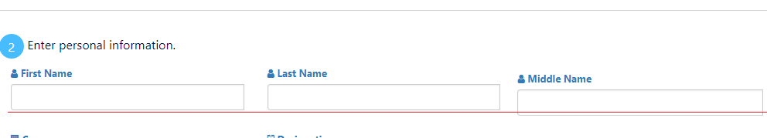

**2. Email label is missing from email field.**

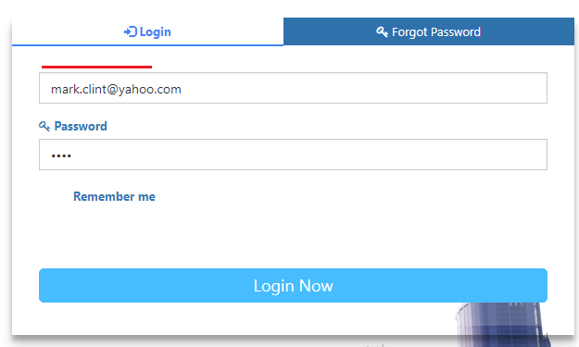

**3. Icons are not working properly in FILTERS.**

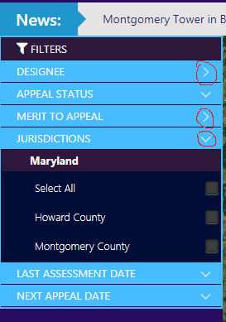

**4. JURISDICTIONS Filter is always open when user navigated to main page.**

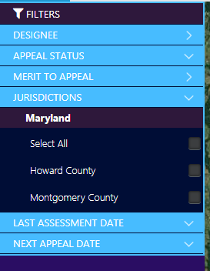

**5. Toggle navigation label is not clearly visible while we check for responsiveness.**

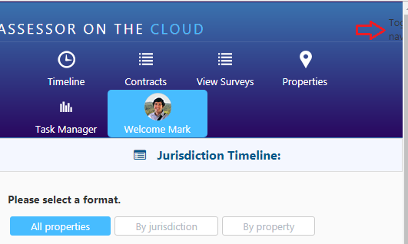

**6. Spelling mistake on view property details from main page.**

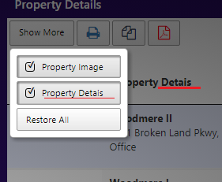

**7. Spelling mistake on jurisdiction timeline page.**

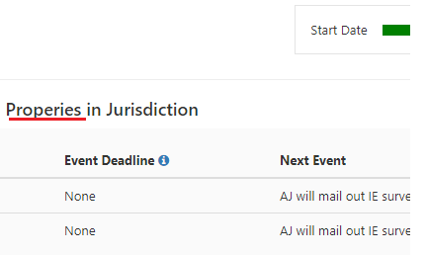

**8. count shows zero but list have contracts on contract list page.**

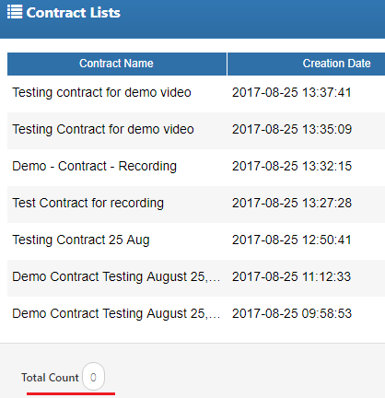

**9. Extra text with fee average on** **Financial Contract Terms page.**

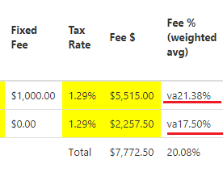

**10. Check boxes are extra-large in size and should give space between check boxes and label on non-financial contract terms page.**

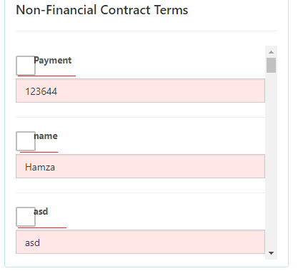

**11. When we check for responsiveness of site only specific tappable area to view toggle navigations but it must have button to view toggle navigations.**

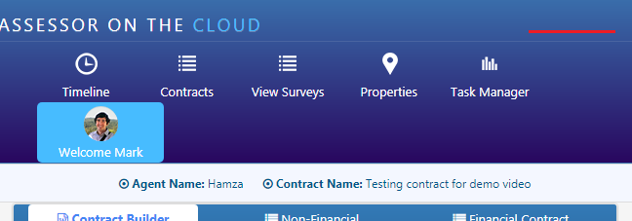

**12. For invalid search system should display an error message “no record found” and total count display 4 surveys.**

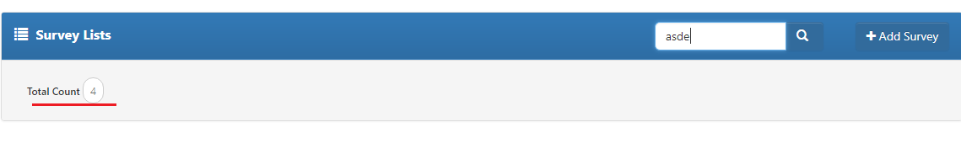

**13.**